NAME- AYUSH A POLADIYA

CLASS- FYDS

ROLL NO- 2317046

SUBJECT – IKS

TOPIC – TRADITIONAL RECIPIES

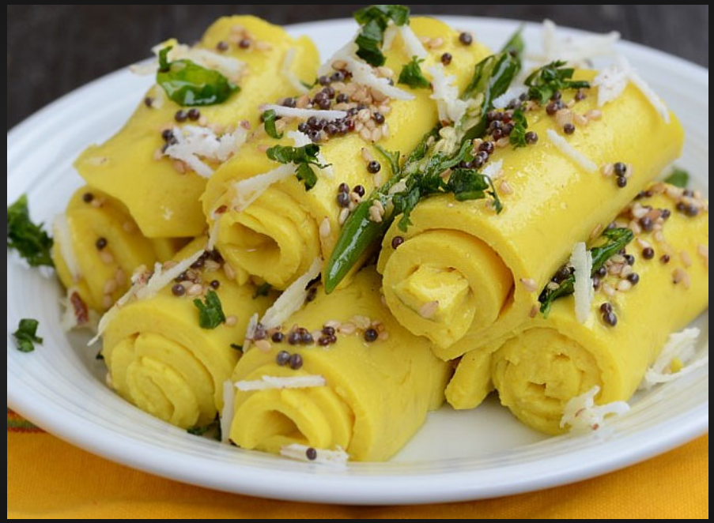

* How khandvi forms a part of Gujrati culture/ food heritage?

Khandvi, a Savory snack made from gram flour and yogurt, is a quintessential part of Gujarati cuisine and culture. Its preparation requires skill and patience, often passed down through generations, making it a cherished tradition in many Gujarati households. Additionally, its delicate texture and flavourful tempering reflect the complexity and richness of Gujarati culinary heritage. Khandvi's presence in festive occasions, family gatherings, and everyday meals further solidifies its status as a cultural icon in Gujarat.

* Recipe of khandvi
* Ingredients:
* 1 cup gram flour (besan)
* 1 cup yogurt
* 2 cups water
* 1 teaspoon ginger paste
* 1 teaspoon green chili paste
* Salt as per taste
* For Tempering:
* 1 tablespoon oil
* 1 teaspoon sesame seeds
* Curry leaves
* Chopped coriander leaves for garnish
* Grated coconut for garnish
* Instructions:
* In a mixing bowl, whisk together gram flour, yogurt, water, ginger paste, green chili paste, and salt until smooth.
* Transfer the mixture to a non-stick pan or and cook over medium heat, stirring continuously to avoid lumps, until the mixture thickens and becomes smooth. This should take about 8-10 minutes.
* Once the mixture is thickened, turn off the heat. Quickly spread a thin layer of the mixture onto the back of a greased plate or a smooth surface.
* Let it cool for a few minutes, then carefully roll it up into a tight cylinder.
* Repeat the process with the remaining mixture.
* Once all the khandvi rolls are made, cut them into bite-sized pieces.
* For the tempering, heat oil in a small pan. Add mustard seeds and let them splutter.
* Then add sesame seeds, asafoetida, and curry leaves. Fry for a few seconds.
* Pour the tempering over the khandvi pieces.
* Garnish with chopped coriander leaves and grated coconut if desired.
* Serve khandvi as a delicious snack or appetizer.

